

Name/id: abdelkareem yousef mamdoh soubar/19110022
Assignment Title: Junior operating system administrator
Course Tutor: Eng. Moath Malkawi
Submission Date: 22-June-2022

google drive for video: https://drive.google.com/drive/folders/1HT03-TciHN1Sv8IJWR1JOGemW5TNPrYb?usp=sharing

q1
a)
best fit is:
job1 -> block1
job2 -> block3
job3 -> block2
because block one is already taken and being used then block three comes because its the biggest and it waists the least then block 2 because its the smallest and it waists the most.

b)
job1 -> block1
job2 -> block2
job3 waiting for block1 or block2 to become available.

because block 1 and 2 fit in the size but block 3 cant fit which means it dose not meet the requirements so it will be taken at last.

q2

In fixed partitioning
the main memory is locked wether you used it all or used non, and each process locks a on a memory which would lead to having wasted memory

In dynamic partitioning
the memory is used according to what the application need and it means that thier is no wasted memory while doing the process

 | Contiguous Memory Allocation | Non-Contiguous Memory Allocation
1 | allocates consecutive blocks of memory | Sapiritly allocates blocks of memory
2 | Fast in execution | Slow in execution
3 | Simple for the OS to control | Hard for the OS to control
4 | Dose not use too much address translation when executing a process | Uses much address translation because there are more overheads
5 | It shows in both of fragmentation and external fragmentation | It only show in external fragmentation
6 | It includes single partition allocation and multi-partition allocation | It includes paging and segmentation
7 | Wastage of memory is there | No memory wastage is there.
8 | Types: 1- fixed partitioning  2- dynamic partitioning | types:  1-Paging  2-Multilevel Paging  3-Inverted Paging  4-Segmentation  5-Segmentated Paging

q3
sudo vi /etc/login.defs

cat /etc/login.defs

(not code) change the pass_max_days to 180

sudo groupadd -g 30000 Students

sudo useradd -G Students Ahmad
sudo useradd -G Students Ali
sudo useradd -G Students Mohammad

sudo passwd Ahmad
password: firstpw
retype: firstpw

sudo passwd Ali
password: firstpw
retype: firstpw

sudo passwd Mohammad
password: firstpw
retype: firstpw

date -d "+180 days"
(not code) Mon April 5 11:49:24 EDT 2014
(not code) copy the date

sudo chage -E 2022-12-07 Ahmad
sudo chage -E 2022-12-07 Ali
sudo chage -E 2022-12-07 Mohammad

sudo chage -M 20 Mohammad

sudo chage -d 0 Ahmad
sudo chage -d 0 Ali
sudo chage -d 0 Mohammad

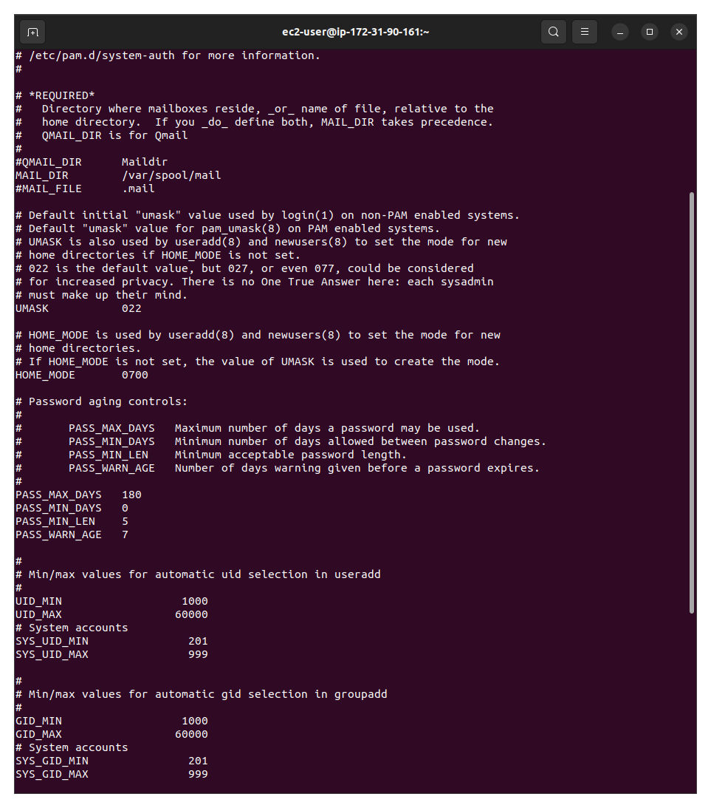
in this terminal it shows the login.defs file that contain the policy for the users

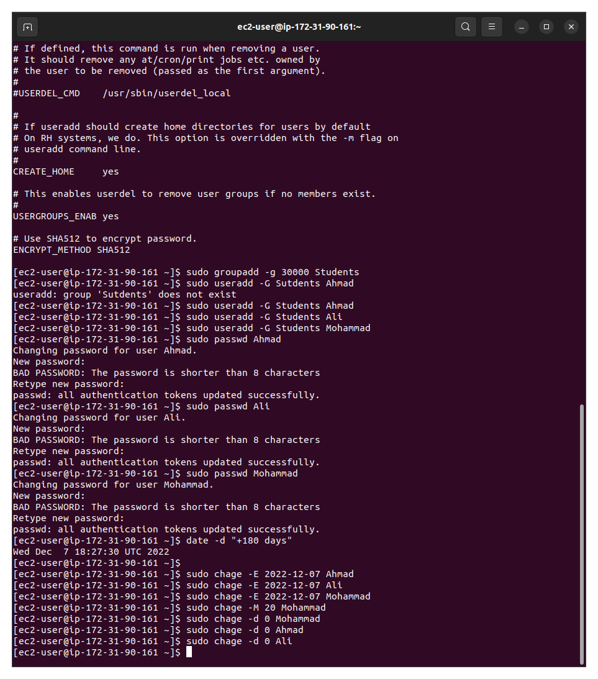
here it shows that the users where added to students group and the password was set
and it shows that user mohamad is going to change his password every 20 days

q4
sudo useradd kareem
sudo usermod -aG wheel USERNAME

yum install php-mysqlnd php-fpm mariadb-server httpd tar curl php-json

sudo yum install php-mysqlnd php-fpm mariadb-server httpd tar curl php-json php7.4 php7.4-gd php7.4-curl

sudo systemctl start mariadb

sudo systemctl start httpd

sudo systemctl enable mariadb

sudo systemctl enable httpd

mysql_secure_installation

sudo mysql_secure_installation

mysql -u root -p

curl https://wordpress.org/latest.tar.gz --output wordpress.tar.gz

tar xf wordpress.tar.gz

cp -r wordpress /var/www/html
sudo cp -r wordpress /var/www/html

chown -R apache:apache /var/www/html/wordpress
chcon -t httpd_sys_rw_content_t /var/www/html/wordpress -R

cp -r /home/Students/wordpress /var/www/html
sudo cp -r /home/Students/wordpress /var/www/html

sudo cp -r /home/ec2-user/wordpress /var/www/html

sudo chown -R apache:apache /var/www/html/wordpress
sudo chcon -t httpd_sys_rw_content_t /var/www/html/

yum install nano
sudo yum install nano
nano /etc/httpd/con.d

sudo chown -R apache:apache /var/www/html
sudo chcon -t httpd_sys_rw_content_t /var/www/html

cp wordpress/** /var/www/html/

q5

su -
password: toor

mkdir /home/Students

chown :Students /home/Students

chmod 2664 /home/Students

ls -ld /home/Students

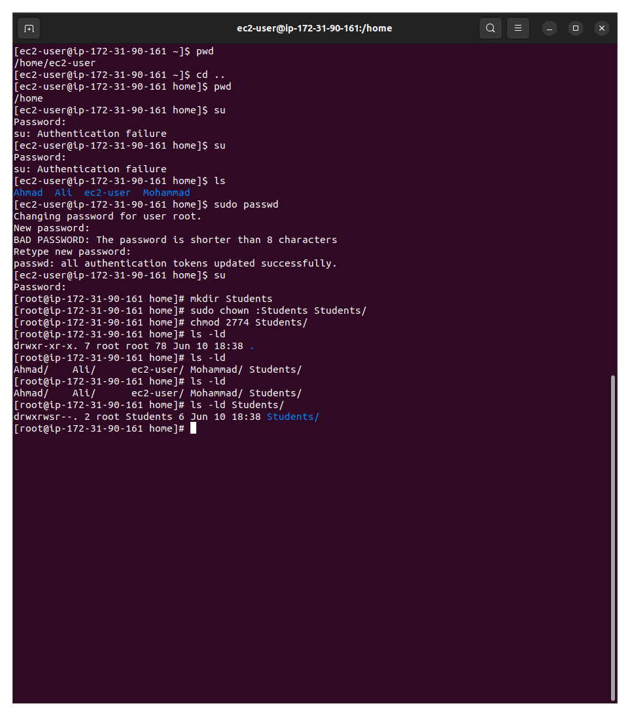
this terminal shows that student directory was created and given to the students group and here in the pic the permissions are set to 2774 but later on where changed to 2664
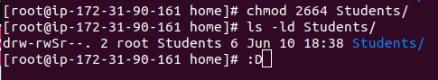
q 6

touch jerry.txt, kramer.txt, george.txt, lex.txt, clark.txt, lois.txt, homer.txt, bart.txt, lisa.txt, marge.txt

mkdir seinfeld
mkdir superman
mkdir simpsons

echo "Jupiter is a planet" > jupiter.txt

ln -s /jupiter.txt /tmp/soft-jupiter.txt

ln jupiter.txt /tmp/hard-jupiter.txt

ls -l jupiter.txt /tmp/hard-jupiter.txt
ls -l jupiter.txt /tmp/soft-jupiter.txt
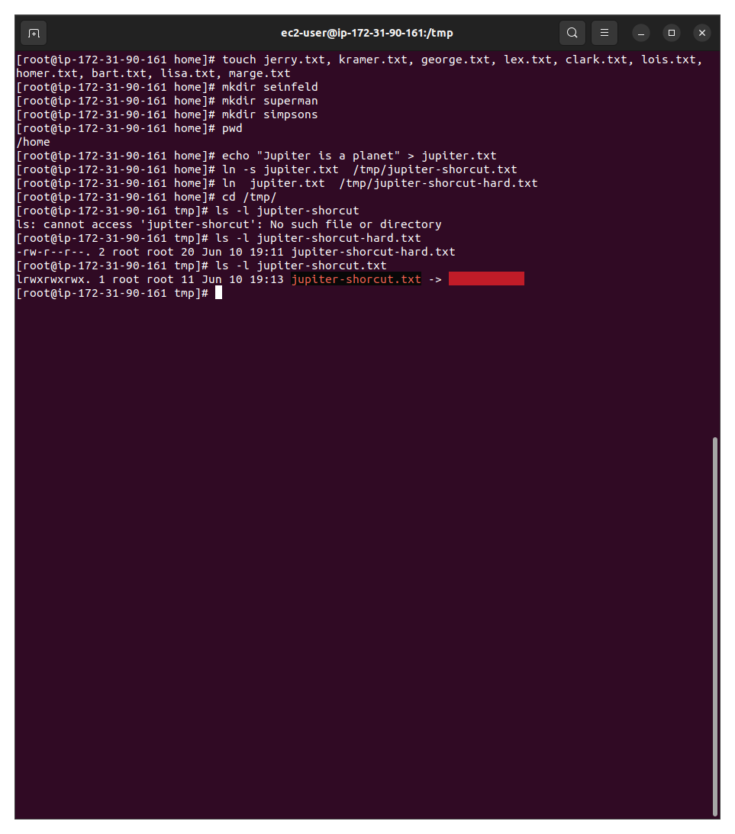

this terminal shows that the files where created plus the directory’s and then the jupiter file was made and created a hard and soft link and they were shown in the picture of the terminal

q7
mkdir /home/kareemsober+ShellScript

crontab -e

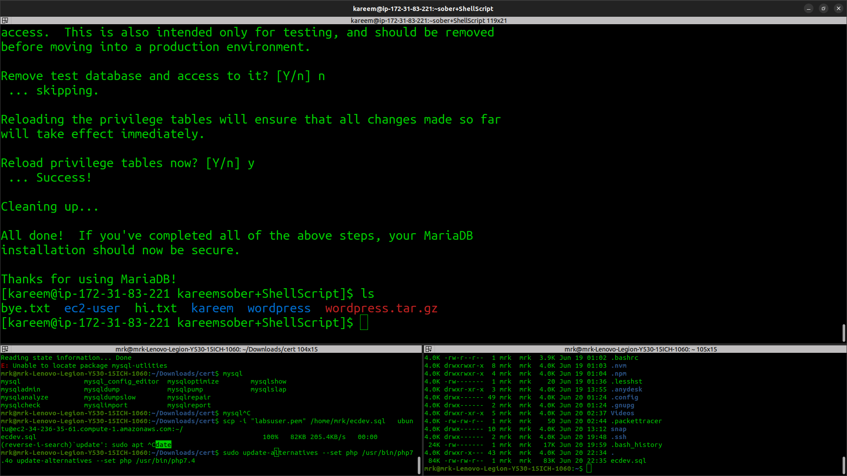
* * * * * find /home -cmin -1 -exec mv -t /home/kareemsober+ShellScript {} + >/dev/null 2>&1

this picture shows that in the file that was created is transferring from home to the new directory

q8

[Net.ServicePointManager]::SecurityProtocol = [Net.SecurityProtocolType]::Tls12

Invoke-WebRequest -Uri "https://www.python.org/ftp/python/3.7.0/python-3.7.0.exe" -OutFile "c:/temp/python-3.7.0.exe"

c:/temp/python-3.7.0.exe /quiet InstallAllUsers=0 PrependPath=1 Include_test=0
I don't think it will work without admin privileges though, I tried using InstallAllUsers=0 to install it only for the current user but it is still asking for elevation.
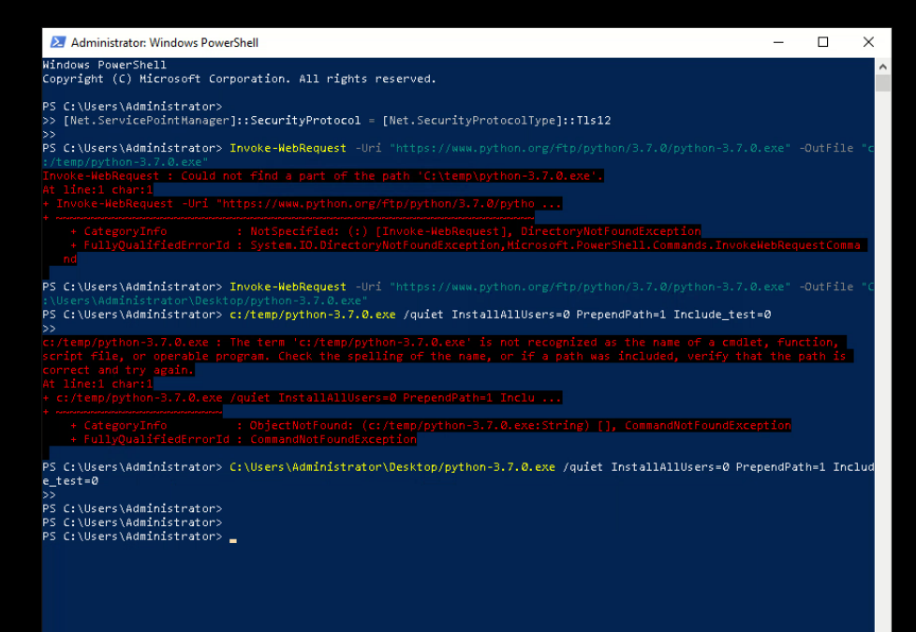
Here it shows that it started by enabling security do be able to download and then started the download
afterwords it installed with quite install that dose the installation in the background
q9

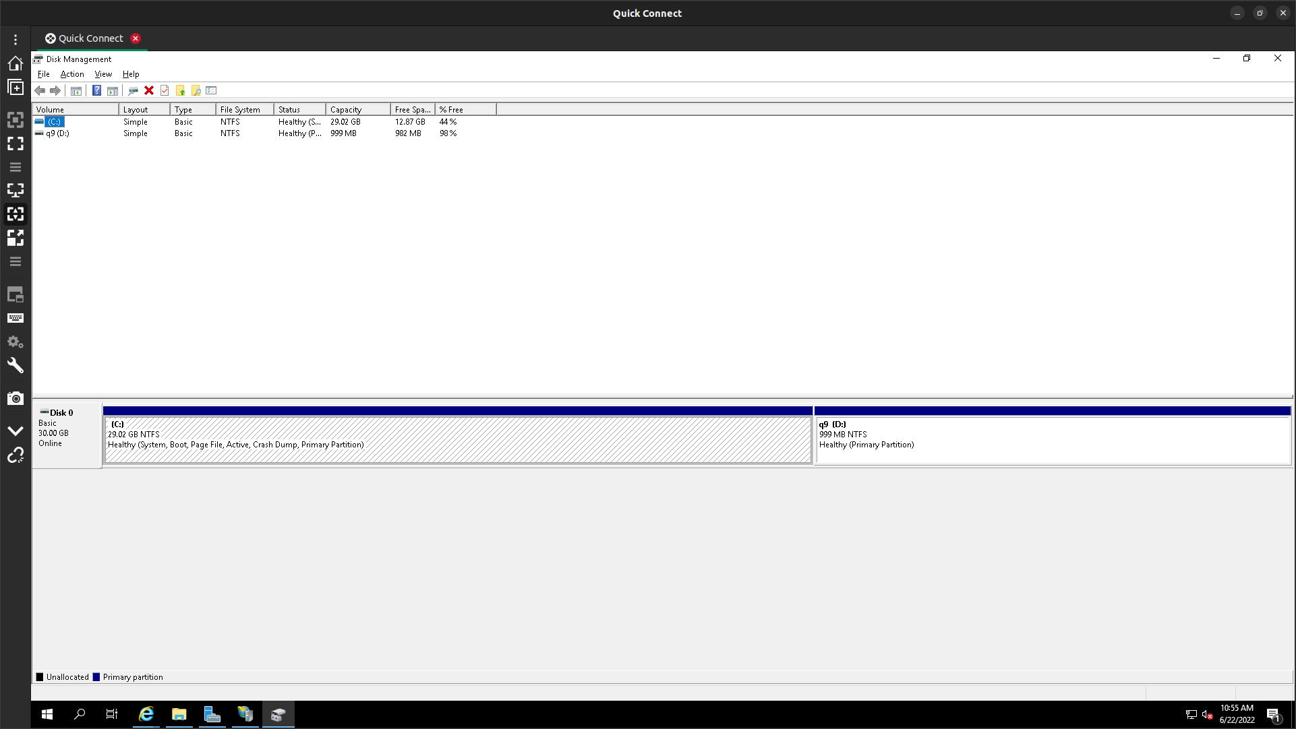
this picture shows that the partitioning is finished and a new partition is set to be used and it was done using shrink as it was explained in the video

q 10

( while true; do echo -n “Add two statement” > ~/output.txt; sleep 1; done) &

jobs

kill -SIGSTOP NUMBER1

kill -SIGCONT NUMBER1

sudo kill number2

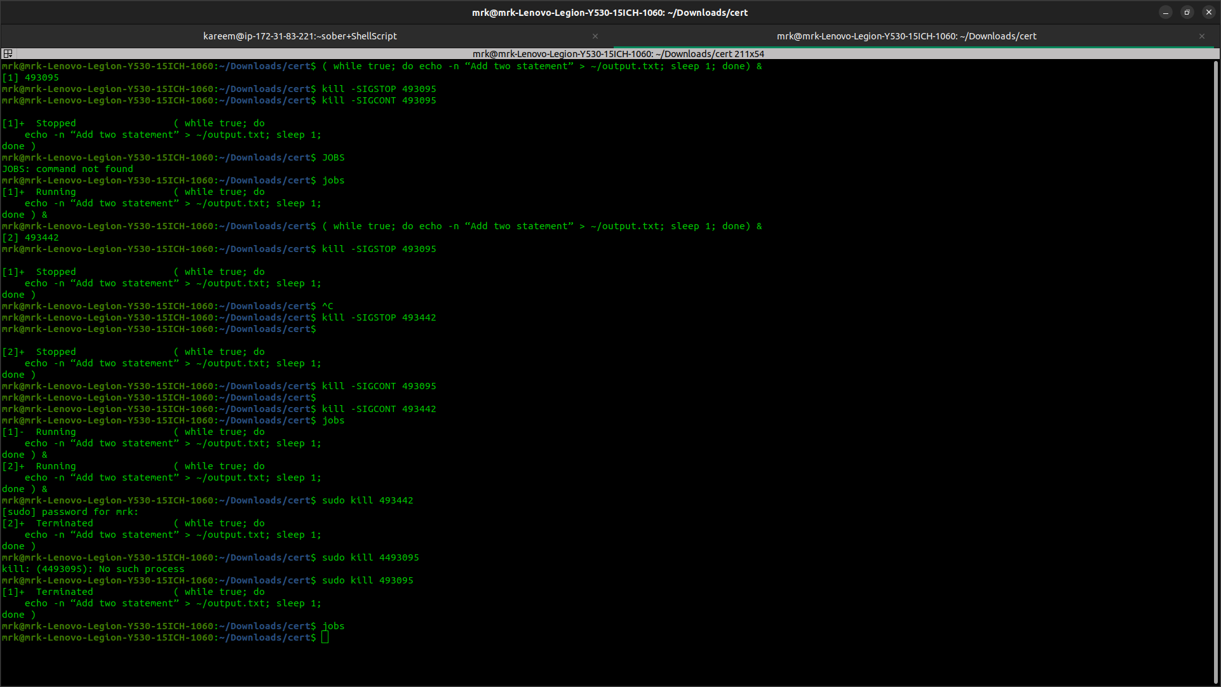
here it shows how both scripts where stoped and continued then terminated which means we can easily control the process

q11

Future of operating systems:
Consider desktops, laptops, smartphones, and other devices in terms of operating systems
development environment.

Operating system is the base (first brick ) in the road of creating a n environment that suites the user now days most of the operating systems are heading towards of making the operating system more human friendly so who ever looks at it would understand how to use it, and because of that many of the available Oss on the market are now user friendly and can be easily customized according to the needs of the buyer.

Developing an operating system at the moment requires great machine power to be able to handle what happens in the operating system in a multiple different methods plus when your using a computer many people can use it with you which means Oss can handle way more than they used to be able to handle.

Introduction of artificial intelligence and impact on operating systems development e.g., mobile
operating systems like Android and iOS equipped with AI-based voice assistants.

there are many different ways to talk about AI and what it can impact on the OS, as for the artificial intelligence, its basically an computer that gets trained to do thing that need thinking from a human but in this case the one that's doing the thinking is a computer/robot, and usually in the case that i went through the AI when it gets trained, it sort of start creating equation for it to function on and based on them it can test it self and give back an accuracy rate but if you train it too much it kind of memorizes the data that your feeding it and gives back 100% rate because it memorized them not learned them, i also have to say that python programming language is mostly used for AI base, because it interact with math with out having much complexity un like other coding langs.

how can operating systems get impacted by using AI tec?, and to answer that i have to start talking about the past before having siri and google, phone used to be really simple and the user had to do everything in the phone on its own even when taking a picture the user had to set the right setting for the camera to take a good picture, and if the user had to set a reminder and alarms the user had to place them.

now days AI can interact with all of those things on its own to a point where it can give advice about your phone usage in relation to your life style, and you can tell your phone to change things in the settings and create new alarm clock and set reminders plus it can give some system status and tell you what to do when having a problem such as storage low, it can tell you what to delete plus when was the app last used

as for personal computers i can mostly walk about windows because it has cortana and mac devices get siri and will be talking about cortana because its way more advanced than siri, their is a project for windows that remove all of Microsoft data collection from windows, for them to be able to do that they had to remove many things such as file manager and i wondered why, apparently cortana(AI) goes through your personal files all the time so it can check for system status so it can control them when its told to, and cortana can be asked to do system check and it would advice and make a schual for disk optimization and old cash/ file removal process, but the user have to say yes, and when you contact Microsoft they can tell your system problem/settings out of the data that is collected in the learning process for cortana so it check your system.

Connectivity e.g., Internet of things.

internet of things is the future of home technology, it controls things with an AI support and it can change things at home for example while your at work such as feeding the dog and heating up the house before you get home from work, and i know its great but it has some really scary things at this moment but later on it would get solved.

internet of things depends on devices around a area such as a house the problem with them is that they connect to wifi not on a different bandwidth which means they can get hacked easily, and when that happens who ever hacked them might just got control over few things in your house.

Support for cloud computing and outsourcing of operating system functions in the cloud.

cloud computing is a very impotent new idea that would build the future of computing, because at low prices your getting computing power, which means you can start testing on computers with out buying them (saving money) you can add as much as you like from a power stand point but it will increase the cost.

security is a very important thing and with cloud computing its a plus , because the mother company had pre installed the highest/best security systems available in the world under your control, it may be hackable but that only works with human error not from the cloud.

over all you would no longer worry about the hardware it self though you would think more about your product.

Open-source operating systems and their impact on future development projects.

Open-source operating system is one of the best things available around the world because your no longer waiting for a company to solve your problem or to check it out, instead you have a community that may get other ideas for you to help you and the mother company would use them to solve their problem or push an update to operating system.

you can also say that the operating system is really based what hte community wants and needs, and the community can help to customize the operating system according to your needs and they might also take some ideas from you.

for the future development all i can say that open source would become more and more used over any thing else because you can add what ever you need from programs to security methods.

Review trends in virtualization, emulation, and use of sophisticated operating systems in
mobile.

virtualization and emulation are a door that would update life of an operating system and turn most of the devices using one operating system and have the old operating systems used in time of need through virtualization and emulation.

in cloud virtualization and emulation it means to get what ever OS you need and use it as if you had it locally plus use it on built ready platform like AWS and if you had enough computing power you can use 2 or more operating systems at the same time.

systems. Security e.g., biometrics.

System that are related to security those days are very important to implement and talk about, and the future of those is very related to what we see and use today.

Today we have biometrics security system installed on the laptop , phones , doors and many many other things and they were built to make that the user is the one who is unlocking the item and their implementations extends to real scenario like online verification, bank accounts which means that this takes effect on the physical side and on the virtual side and it making the world more secured place

Multi-modal interaction e.g., touch, type, speech. User centered design.

They way human interact with things is a really big deal thing to be thinking about those days because its the way that defines your product and how people will like it or not for example windows is loved by many people but Linux is loved mostly by developers that's because windows focused on the interface but at the same time Linux didn’t tell the last few years when gnome started getting updates and feed back on how to use it and why to use Linux,
we also have to include physical hardware that comes along such eye print and finger print, audio , screen size no delay all of those didn’t come out of no where they came because people needed those things to be used in their life.

Automation of common tasks based on user habits

now a days many companies are starting to use automation to increase their productivity and be able to produce more with high rate of accuracy, and less people would be evolved in the production process which would element the human error rate and that's a very good thing for companies.

what about people?, now a day people are starting to buy machines to make there life simpler, but at the same time they are getting more and more lazy and that a problem for many people, for example lately many people are starting to buy coffee machines that are operating through an app in the phone, many people think its a good simple way to get coffee in the morning and i agree, but what i don't agree on that when the machines goes down for what ever reason they get lazy to make it on their own, and you can use this example on other things in life.

people are getting more stupid, and by that i mean with technology people are using their brains less and less for example now people are starting to use their cameras to solve math equation, i do agree on that its a good thing but at the same time people are starting to become slower and some of them are not even learning the thing their just revealing entirely on the tec.

people are starting to know less because their life is starting to depend on the automation machines in their day to day life, and i know that its a good thing to make a life easier but when the tec is used incorrectly it can have some fatly effects on people.

q12
today I am going to talk about 2 main operating system on the market today in which are windows and Linux based operating systems

functionality

windows

we are going start with windows and when it comes to functionality windows is really comfortable when it comes to doing creative work and creating some designs and there are main stream companies like photo-shop and auto-disk that have there programs running on windows and not available for Linux (they mainly use windows for those programs and they were built for it) as for Linux operating system same software may be able to run with some tricks but they would function way better on windows.

linux

Linux based operating system is way more comfortable when it comes to development, because its based on UNIX and UNIX uses bash and bash have way more command and it was designed to do things in more easy way with less written lines of code that for the star of UNIX now days it Linux and the difference is that its the same as UNIX but its themed with GUI support which means now it has an interface and it can be used for almost every thing but for development the bash script is easy to create and the terminal program is simple and easy to use and it can interact with all elements from the operating system and Linux is an open source operating system it can be used by anyone for every one to customize it the way they like and make even more suitable for devolvement.

as for software support for Linux almost everything exists but its more suitable for code math and AI than graphics related things because in the old day Linux was and still better under the hood but windows was faster in creating the interface part (GUI) and it came first and most of the companies were using windows OS for everything and ever sense windows had better support from other companies on everything was related to graphics as for Linux which was UNIX, GUI was interudused very late comparing to windows and it was really good for development and free to people and Linux really depends on county work not one company's work/effort and by the time Linux came out with GUI windows had years of experience in GUI and Windows's GUI was way better.

so Linux never focused on GUI but it was sole worker to a point that all of the scientific work is on Linux and 95% of the world servers are Linux.

so in conclusion Linux is way better/comfortably for Dev work and windows beats Linux in design and creative work.

interface

windows

windows GUI is the most comfortable GUI was ever built with consecration of eye comfort to FPS to animation in the GUI it self because Microsoft focused on human interaction when it comes to GUI and they collected tons of data for the GUI and put in to mind what people did to change their interface and made it as an option but having all of that into mind it takes a huge load on the device to run windows GUI and windows is mostly used by using the GUI not CMD(power shell) because most of its program use the interface as a main source of interaction with the OS, because of that using power shell is not common and not many people know how to used.

that's why windows is well known for its interface and it being used a lot (all the time).

Linux

Linux GUI is not as advanced as Windows's GUI but its built with customization in mind and by that i mean Linux is open source which means any person can edit the base code for almost anything and add to it.

so yes Linux GUI is not desirable for normal people but for developers, its amazing because it can be customized according to the they are doing in OS and it can be edit and add addons to the GUI so it can suit the case that he's in and it would be built in a way that only him would be very comfortable with it.

in Linux you would need to know some bash to be able to use it daily and most of the thing you install if not all are on the terminal plus the store it self is a bit more limited comparing to windows but if you add repo's it updates it self and you get more stuff unlike windows that is closed source (non editable).

you can create indicator for things that you consider important in the GUI and create other type of indicators that can indicate on deferent OS's or operating systems about it status or whatever you built.

and
design

windows

is based on a closed source idea which means whatever the mother company do is what you do and use, its a very controlled environment by the mother company and in this case its Microsoft, and because of this a lot happens under the hood is not shown to people and if anyone tries to get creative with the OS you would be breaking the law, but it also means that the OS works according to the mother company that usually releases good updates and can keep the OS more stable than any other option, but it also means that they can break it when they like for example when its old so you would get the newer/ updated one.

Linux

is based on open source idea which means that everything goes under the hood is something the community knows about and its being secured, and in case of having any problem in the OS, you don't have to wait for the mother companies/destro to solve it, you can check what other people done and check other solutions for the problem, plus you can post it to get other people help in your problem, and you create and edit the OS according to your need and liking.

References

Duan, Lu-Ming, and Guang-Can Guo. “Reducing Decoherence in Quantum-Computer Memory with All Quantum Bits Coupling to the Same Environment.” Physical Review A, vol. 57, no. 2, 1 Feb. 1998, pp. 737–741, 10.1103/physreva.57.737.

Heegard, C., and A.E. Gamal. “On the Capacity of Computer Memory with Defects.” IEEE Transactions on Information Theory, vol. 29, no. 5, 1 Sept. 1983, pp. 731–739, ieeexplore.ieee.org/abstract/document/1056723, 10.1109/TIT.1983.1056723. Accessed 22 June 2022.

JasonGerend. “Shrink a Basic Volume.” Docs.microsoft.com, docs.microsoft.com/en-us/windows-server/storage/disk-management/shrink-a-basic-volume.

Kommadi, Bhagvan. “AI Operating System.” Medium, 20 Jan. 2020, medium.datadriveninvestor.com/ai-operating-system-7809e7fc4e49.

Pothecary, Mark. “Software Development, Operating Systems, and Development Environments.” Medium, 1 Apr. 2019, medium.com/@pothers22/software-development-operating-systems-and-development-environments-25f1ad6f0d99. Accessed 22 June 2022.

Shor, Peter W. “Scheme for Reducing Decoherence in Quantum Computer Memory.” Physical Review A, vol. 52, no. 4, 1 Oct. 1995, pp. R2493–R2496, 10.1103/physreva.52.r2493.

Stone, Harold S. “A Logic-In-Memory Computer.” IEEE Transactions on Computers, vol. C-19, no. 1, 1 Jan. 1970, pp. 73–78, ieeexplore.ieee.org/abstract/document/5008902, 10.1109/TC.1970.5008902. Accessed 22 June 2022.

Zdravkova, Katerina. “The Potential of Artificial Intelligence for Assistive Technology in Education.” Learning and Analytics in Intelligent Systems, 2022, pp. 61–85, 10.1007/978-3-031-04662-9_4. Accessed 22 June 2022.

